# Introduction:

Example QMBE 1320 – Final Project

By

Group Member 1 and Group Member 2

Per capita income and expenditures provide crucial insight into the average standard of living in specified areas. Disposable per capita income measures the average income earned after taxes per person in a given area (city, state, country, etc.) in a specified year. It is

Background

HOOK

calculated by dividing the area’s total income after tax by its total population. Per capita expenditures, on the other hand, measures the average outlay for goods and services by person and provides insight into spending patterns across a given area. Together, the assessment of per capita income versus expenditures can provide better understanding of regional economies, differences in standard of living, and approximate savings rates.

Why Important

This project involves exploring [Bureau of Economic Analysis](http://www.bea.gov/index.htm) data regarding [per](http://www.bea.gov/iTable/iTableHtml.cfm?reqid=70&step=30&isuri=1&7022=21&7023=0&7024=non-industry&7033=-1&7025=0&7026=00000%2C01000%2C02000%2C04000%2C05000%2C06000%2C08000%2C09000%2C10000%2C11000%2C12000%2C13000%2C15000%2C16000%2C17000%2C18000%2C19000%2C20000%2C21000%2C22000%2C23000%2C24000%2C25000%2C26000%2C27000%2C28000%2C29000%2C30000%2C31000%2C32000%2C33000%2C34000%2C35000%2C36000%2C37000%2C38000%2C39000%2C40000%2C41000%2C42000%2C44000%2C45000%2C46000%2C47000%2C48000%2C49000%2C50000%2C51000%2C53000%2C54000%2C55000%2C56000&7027=-1&7001=421&7028=53&7031=0&7040=-1&7083=levels&7029=23&7090=70) [capita disposable income](http://www.bea.gov/iTable/iTableHtml.cfm?reqid=70&step=30&isuri=1&7022=21&7023=0&7024=non-industry&7033=-1&7025=0&7026=00000%2C01000%2C02000%2C04000%2C05000%2C06000%2C08000%2C09000%2C10000%2C11000%2C12000%2C13000%2C15000%2C16000%2C17000%2C18000%2C19000%2C20000%2C21000%2C22000%2C23000%2C24000%2C25000%2C26000%2C27000%2C28000%2C29000%2C30000%2C31000%2C32000%2C33000%2C34000%2C35000%2C36000%2C37000%2C38000%2C39000%2C40000%2C41000%2C42000%2C44000%2C45000%2C46000%2C47000%2C48000%2C49000%2C50000%2C51000%2C53000%2C54000%2C55000%2C56000&7027=-1&7001=421&7028=53&7031=0&7040=-1&7083=levels&7029=23&7090=70) (hereafter referred to as PCI) and [per capita personal](http://www.bea.gov/iTable/iTableHtml.cfm?reqid=70&step=10&isuri=1&7003=2&7035=-1&7004=x&7005=1&7006=00000%2C01000%2C02000%2C04000%2C05000%2C06000%2C08000%2C09000%2C10000%2C11000%2C12000%2C13000%2C15000%2C16000%2C17000%2C18000%2C19000%2C20000%2C21000%2C22000%2C23000%2C24000%2C25000%2C26000%2C27000%2C28000%2C29000%2C30000%2C31000%2C32000%2C33000%2C34000%2C35000%2C36000%2C37000%2C38000%2C39000%2C40000%2C41000%2C42000%2C44000%2C45000%2C46000%2C47000%2C48000%2C49000%2C50000%2C51000%2C53000%2C54000%2C55000%2C56000&7036=-1&7001=62&7002=6&7090=70&7007=-1&7093=levels) [expenditures](http://www.bea.gov/iTable/iTableHtml.cfm?reqid=70&step=10&isuri=1&7003=2&7035=-1&7004=x&7005=1&7006=00000%2C01000%2C02000%2C04000%2C05000%2C06000%2C08000%2C09000%2C10000%2C11000%2C12000%2C13000%2C15000%2C16000%2C17000%2C18000%2C19000%2C20000%2C21000%2C22000%2C23000%2C24000%2C25000%2C26000%2C27000%2C28000%2C29000%2C30000%2C31000%2C32000%2C33000%2C34000%2C35000%2C36000%2C37000%2C38000%2C39000%2C40000%2C41000%2C42000%2C44000%2C45000%2C46000%2C47000%2C48000%2C49000%2C50000%2C51000%2C53000%2C54000%2C55000%2C56000&7036=-1&7001=62&7002=6&7090=70&7007=-1&7093=levels) (hereafter referred to as PCE). The PCI data provides annual (non-inflation adjusted) per capita disposable income at the national and state-level from 1948-2015 and the PCE data provides annual (non-inflation adjusted) per capita personal consumption expenditures at the national and state-level from 1997-2014. Consequently, this

Problem Statement(s)

Describe Data and Source

research seeks to identify how the national and state-level savings rates defined as

𝑆𝑎𝑣𝑖𝑛𝑔𝑠 = 𝑃𝐶𝐼 − 𝑃𝐶𝐸 has changed over time and by geographic location. The primary purpose of this analysis is to assess how national and state-level

PCI, PCE, and savings rates have changed over time and by geographic location. To assess national trends, we plot national PCI and PCE together in a time-series plot. We also calculate the national level savings rate and plot it in a graph over time. To assess the state-level PCI, we map the savings rate for each state in year panels to see the differences across the country. Also, we plot the savings rate for each state over time, while highlighting the top ten and bottom ten states in the country. Lastly, we calculate

How Analysis is Done

the change in savings rate for each state and report the ten states with the largest change in savings in a table.

The analysis finds that the national-level and average state-level savings rates have remained around 7-8% since 1997. Furthermore, we find that American’s are not making fundamental shifts in their earnings and expenditure rates. However, the analysis does uncover a noticeable shift in the disparity of savings rates across the states in recent years with much of the growth in savings rates being concentrated in the central U.S. states - from the Dakotas down to Oklahoma, Texas and Louisiana.

OPTIONAL:

Summary of findings.

Consequently, it appears that the often-neglected fly-over states offer Americans greater opportunities to save than the eastern and western states.

# Data Preparation:

Prior to assessing how PCI, PCE, and savings rates have behaved over time and by geographic location we must acquire and clean the data.

Source of Data

The data for this project originated from the following sources:

* PCI data: <http://bit.ly/2dpEPY1>
* PCE data: <http://bit.ly/2dhC89U>

**Cleaning Data:** Once the basic data has been acquired we need to pre-process it to get the data into a [tidy format](http://vita.had.co.nz/papers/tidy-data.html). This includes removing punctuations, changing the income and

Specific Data Cleaning Steps

expenditure data from character to a numeric data type, reducing the data sets to the same time period (1997-2014), making sure the common variables share the same names, and changing the data from a wide format to a long format. Once this has been done for both the PCI and PCE data we can merge the clean data frames into one common data frame (titled *data_clean*) and create a new *Savings* variable

(𝑆𝑎𝑣𝑖𝑛𝑔𝑠 = 𝐼𝑛𝑐𝑜𝑚𝑒 − 𝐸𝑥𝑝𝑒𝑛𝑑𝑖𝑡𝑢𝑟𝑒𝑠). I also remove the District of Columbia location since this is more comparable to metropolitan-level geographic areas than state-level geographic areas. We now have the data cleaned, in a tidy format, and ready to analyze as Table 1 illustrates.

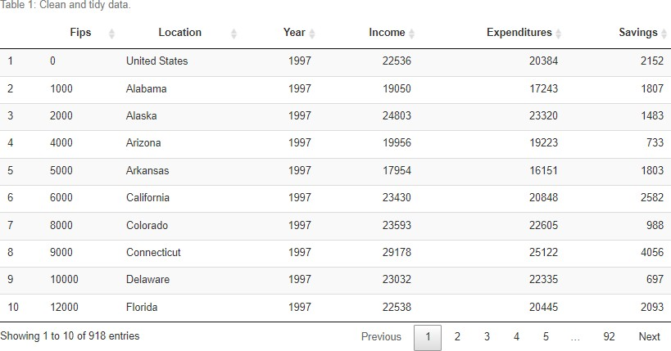

1. Capitalized Columns
2. Colored Rows
3. Centered Figure
4. Good Size
5. Data-Ink Ratio (No column Lines)

# Exploratory Data Analysis:

The primary purpose of this analysis is to assess how national and state-level PCI, PCE, and savings rates have changed over time and by geographic location. Thus, we will proceed by first assessing the national-level trends and then move on to assessing state-level trends.

## National Level Patterns:

At the national-level PCI grew by 79.6% from $22,536 in 1997 to $40,471 in 2014. Expenditures (PCE), on the other hand, grew 82.5% from $20,384 in 1997 to $37,186. Although we are assessing non-inflation adjusted dollars, we can still observe that since 1997 the rate of growth in PCE has only slightly outpaced PCI. Figure 1 illustrates the growing trends (not surprising since inflation has not been removed) and also captures the decrease in both PCI and PCE from 2008 to 2009 due to the [Great Recession](https://en.wikipedia.org/wiki/Great_Recession).

Figure 1 as Proof

First Finding

However, a closer look at just the savings rate (𝑆𝑎𝑣𝑖𝑛𝑔𝑠𝑅𝑎𝑡𝑒 = 𝑆𝑎𝑣𝑖𝑛𝑔𝑠) depicted in

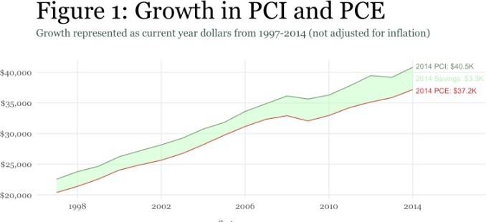

1. Clear Title
2. Need Axis Titles or Legend
3. No Variable Names!
4. Centered

𝐼𝑛𝑐𝑜𝑚𝑒

Figure 2 illustrates that no consistent trend has been established. In other words, the aggregate per capita savings rate has not consistently increased or decreased year- over-year. In 1998 the savings rate was 10% but reduced over the next few years to 6.5% in 2005 before peaking at 10.9% in 2012 and then dipping back down to about 8-9% in recent years. Bottom-line is that since 1997 the national-level per capita savings rate has ranged between 6.5% and 10.9% with an average of 8.6%.

Additional Finding and Proof

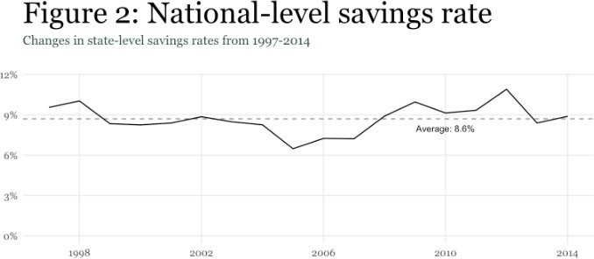

Good Transition!

However, understanding aggregate ratios and trends provides limited insight regarding

lower-level activity [1.](https://rstudio-pubs-static.s3.amazonaws.com/215415_30acfda661154e40bf762cc0c33d2283.html#fn1) Consequently, next we turn to investigating state-level trends.

## State Level Patterns:

To get a quick understanding of how U.S. states have progressed over the years we can map the savings rates over time. Figure 3 highlights a few attributes:

1. Note how the earlier years have less diverging colors suggesting that there was more “equality” in the savings rates across the states; however, the latter years appear to have more disparity in the savings rates
2. As the years have progressed it appears that a growth in savings rates has been concentrated in the central states; primarily from the Dakotas down to Texas

Another finding and Proof

1. A few individual states stand out:

age

ap it

Another finding and Proof

* + Main, Vermont & Montana for savings rates that are consistently less than 0%
  + Massachusetts for consistently being a top savings rate state

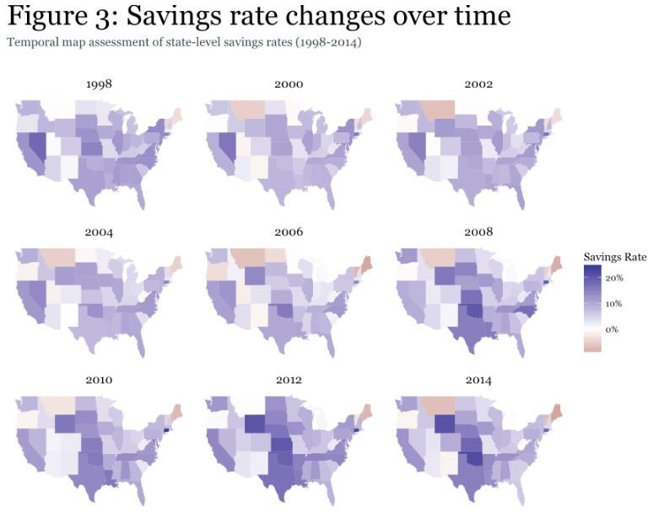

1. Clear Title
2. Axis Titles or Legend
3. No Variable Names!
4. Centered 5.Good use of color

6. Good Size

A closer look at the state-level trends provides more insight. We can see that the aver savings rate over time has remained around 7%; however, confirming our assessment of the m appears that the variance (or disparity in savings rates) has increased in recent years. Moreover, the trend lines illustrate that with a few exceptions, states that are leading the way as top or bottom savings rate states have, historically, always been near the top or bottom. However, this should not be too surprising as it takes decades for states to change their industrial and economic infrastructure.

1. Clear Title
2. Axis Titles or Legend
3. No Variable Names!
4. Centered 5.Good use of color

6. Good Size

However, we can also look at those states that have had the largest change in their savings rate since 1997. As Table 2 displays, three of the four states with the largest change in their savings

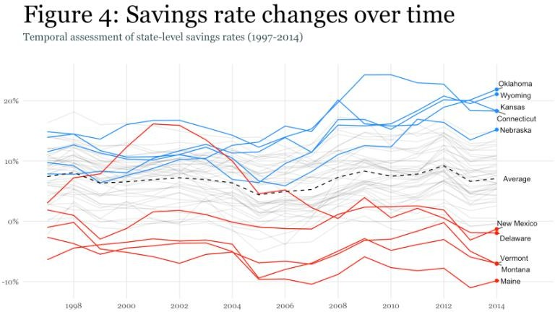

Another finding and Proof

rate were Wyoming, Oklahoma and North Dakota; all having a savings rate increase close to, or more than, 10%. The remaining states with the largest changes have all experienced declining savings rates, led by Nevada.

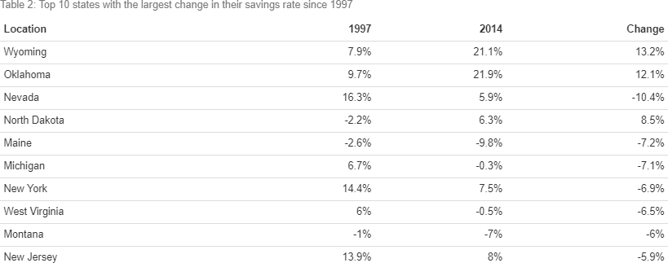

1. Clear Title
2. No Variable Names!
3. Not Cut by page
4. Centered 5.Data-ink Ratio
5. Good Size
6. Could use

This may lead us to wonder if one component (PCI vs PCE) is driving the changes in savings rate. In other words, for those states that are growing above the average level, is their PCI level growing at a greater level than those states below the average? Or could it be that the those states with above average savings rates are experiencing a slower increase in their expenditures than those states below average. Figure 5 helps to illustrate this issue.

Figure 5 shows that, concerning PCE (left pane), the states that have had above average saving rates have not experienced, on average, any difference in PCE growth since 1997. However, the states with below average savings rates have experienced greater variance in their PCE growth rates. Concerning PCI (right pane), the states that have had above average savings rates have experienced, on average, slightly greater PCE growth since 1997; however, this difference is likely not to be statistically significant (though validation would be required to confirm). Again, those states with below average savings rates have experienced slightly greater variance in their growth rates than the above average savings rate states.

s

Finding and Proof

Observation and Transition

Thus, it appears that those states with below average savings rates have greater variability in their PCI and PCE growth rates whereas those states with above average savings rates have more consistency. However, no significant differences appear to exist in the average PCI & PCE growth rates among states with above versus below average savings rate. This is likely why we are seeing the average savings rate remain relatively steady but the variability in savings rates among the states growing.

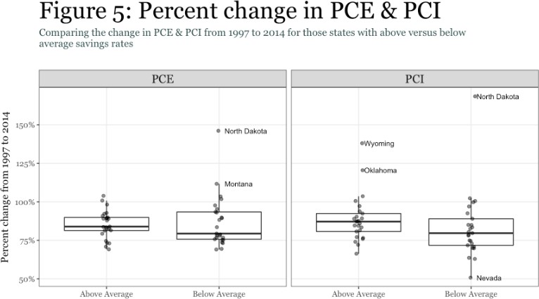

## Summary:

1. Clear Title
2. No Variable Names!
3. Not Cut by page
4. Centered
5. Good Size
6. Could use color but still easy to read
7. Axis Titles/Legend

This project involves examining data from the Bureau of Economic Analysis, specifically focusing on per capita disposable income (PCI) and per capita personal expenditures (PCE). The PCI data covers annual (non-inflation adjusted) per capita disposable income at the national and state levels from 1948 to 2015, while the PCE data covers annual (non-inflation adjusted) per capita personal consumption expenditures at the national and state levels from 1997 to 2014. The research aims to understand how the savings rate, defined as Savings = PCI - PCE, has evolved over time and

across different geographic locations.

The main objective of this analysis is to evaluate changes in national and state-level PCI, PCE, savings rates over time and across regions. To examine national trends, we created a time-seri

and es

e

### Summarize

whole project

plot that illustrates national PCI and PCE over the specified period. Additionally, we calculated th national savings rate and presented it graphically to observe trends over time.

For state-level analysis, we created a map of savings rates for each state in year panels to visualize variations across the country. We also plotted the savings rates for each state over time, emphasizing the top ten and bottom ten states. Lastly, we calculated the change in savings rate for each state and compiled a table highlighting the ten states with the most significant changes in savings. This comprehensive approach allows us to assess and compare savings dynamics both nationally and at the state level.

Consequently, our analysis finds that the national-level and average state-level savings rates ha remained around 7-8% since 1997. Furthermore, we find that PCI and PCE have grown at a relatively similar rates at the national, state-levels, and among those states that have experience above versus below average savings rates. This suggests that the U.S. has not experienced a fundamental shift in PCI or PCE behavior.

ve

d

Summarize findings

The noticeable change that we have seen is a greater disparity in savings rates among the states in recent years. Although the average savings rate has remained around 7-8%, the variance in state- level savings rates has grown since 1997. Moreover, much of the above average growth in savings rates has been concentrated in the central U.S. states from the Dakotas down to Oklahoma, Texas and Louisiana; whereas much of the below average growth has been concentrated in more eastern and western states. Thus, if you are looking to save more of your hard-earned income you may have greater opportunities by seeking refuge in one of the fly-over states.

Conclusion statement

|  |  |  |  |
| --- | --- | --- | --- |
| This study has limitations, including a gap in overlapping years between PCI and PCE data, the absence | | | |
| of inflation adjustments, potential inconsistencies in state-level data reporting, a simplistic approach to | | | |
| calculating savings rates, and a challenge in establishing clear causation between changes in PCI, PCE, | | |  |
| and savings rates. To improve this study, one could use more consistent data coverage, apply inflation | | | |
| adjustments, refine the state-level analysis by addressing potential variations, incorporate additional | | | |
| economic factors influencing savings rates, and communicate the study's limitations in establishing | | | |
| causation while considering further research or sensitivity analyses. These enhancements would | |  | |
| contribute to a more comprehensive and accurate understanding of the trends in per capita disposable | | | |
| income, personal expenditures, and savings rates over time and across geographic locations. |  | | |

Summarize limitations and improvements